**15/11/2021 CN SPOT 10 2019103573**

**SIMPLE LAN NETWORK**

**A simple LAN network with 5 nodes , flow of UDP pack from node0 to node3,**

**And flow of TCP packets from node2 to node5**

**Ns2 code:-**

set ns [new Simulator]

set tracefile [open LAN.tr w]

$ns trace-all $tracefile

set namfile [open LAN.nam w]

$ns namtrace-all $namfile

set n0 [$ns node]

set n1 [$ns node]

set n2 [$ns node]

set n3 [$ns node]

set n4 [$ns node]

set n5 [$ns node]

$ns duplex-link $n0 $n1 5Mb 2ms DropTail

$ns duplex-link $n2 $n1 10Mb 4ms DropTail

$ns duplex-link $n1 $n4 3Mb 10ms DropTail

$ns duplex-link $n4 $n3 100Mb 2ms DropTail

$ns duplex-link $n4 $n5 4Mb 10ms DropTail

set UDP [new Agent/UDP]

set null [new Agent/Null]

$ns attach-agent $n0 $UDP

$ns attach-agent $n3 $null

$ns connect $UDP $null

set TCP [new Agent/TCP]

set sink [new Agent/TCPSink]

$ns attach-agent $n2 $TCP

$ns attach-agent $n5 $sink

$ns connect $TCP $sink

set cbr [new Application/Traffic/CBR]

$cbr attach-agent $UDP

set ftp [new Application/FTP]

$ftp attach-agent $TCP

$ns at 1.0 "$cbr start"

$ns at 2.0 "$ftp start"

$ns at 10.0 "finish"

proc finish {} {

global ns tracefile namfile

$ns flush-trace

close $tracefile

close $namfile

exit 0

}

puts "LAN Network with 5 nodes"

puts "CBR connection UDP packets flow from node0 to node3"

puts "FTP connection TCP packets flow from node2 to node5"

$ns run

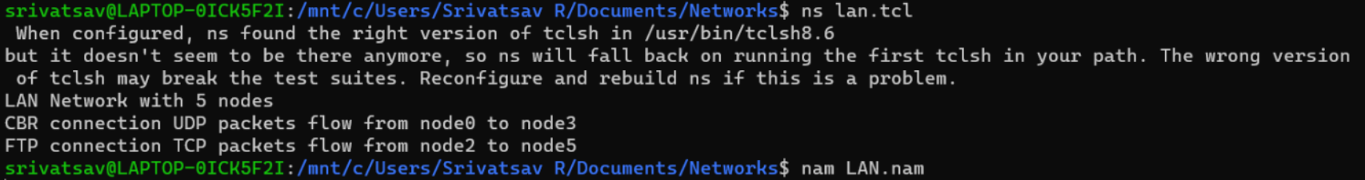**OUTPUT**

**VISUALIZATION**

**LAN SETUP**

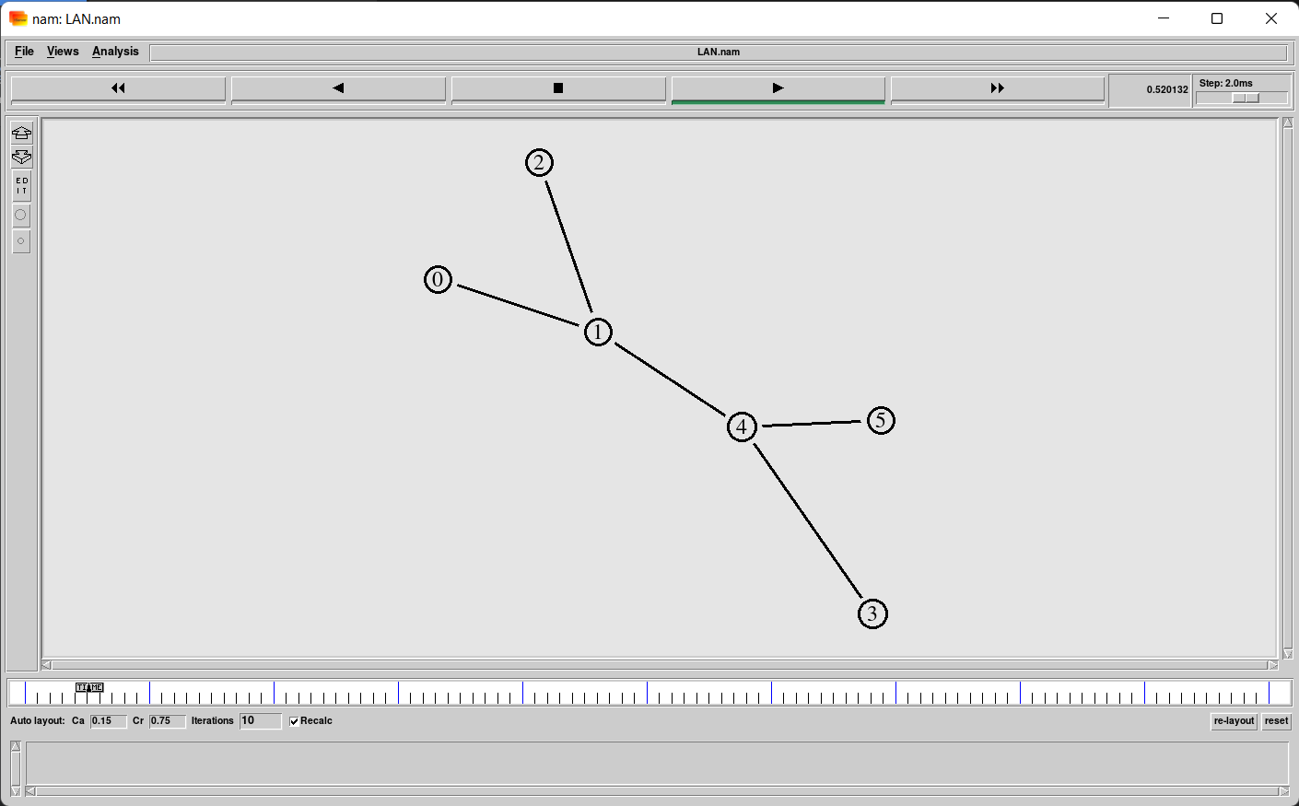

**Flow of UDP packets from node0 to node3:**

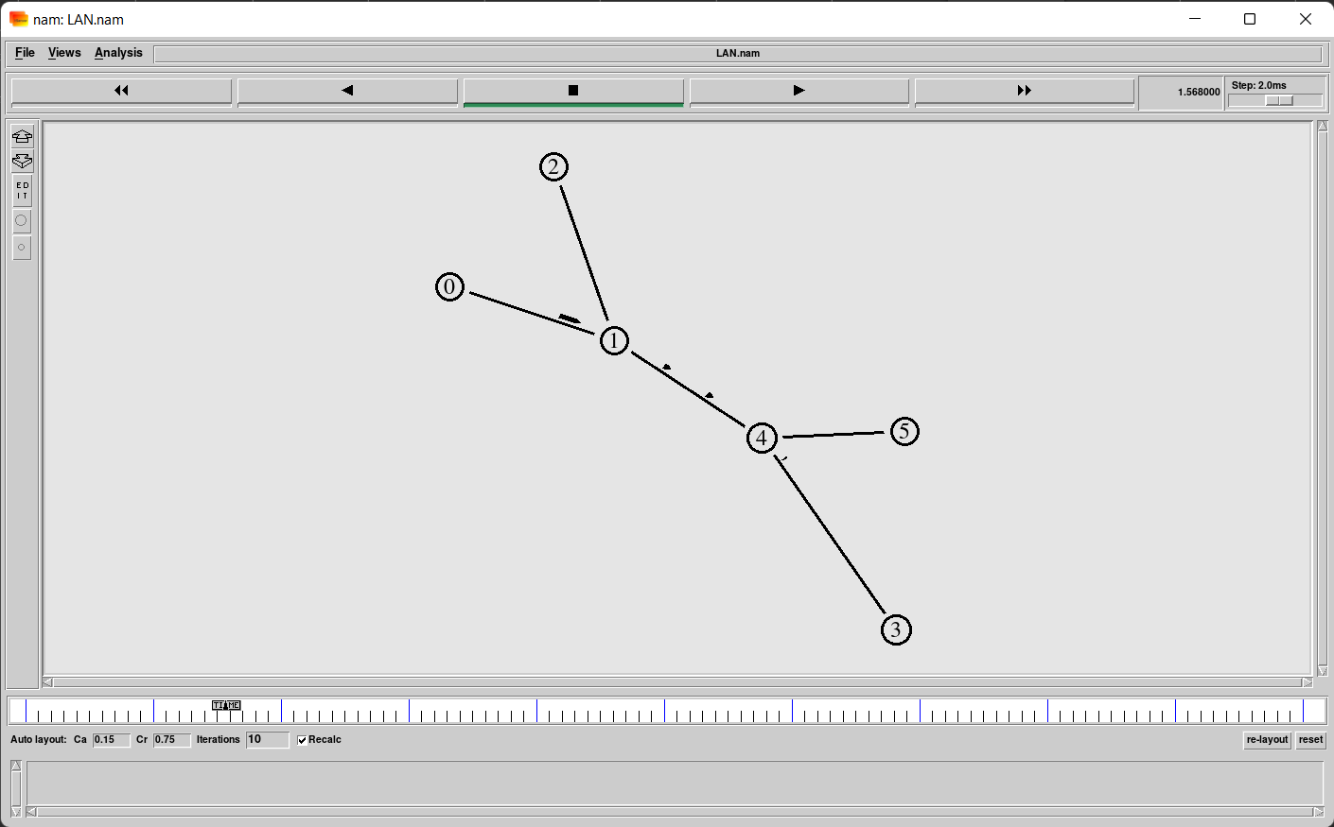

**Flow of TCP packets from node2 to node5 and UDP packets from node0 to node3 simultaneously:**

